**Computer Science Department  
Prairie View A&M University**

**Senior Design Project:**

**PV Parking**

**Mariah Fontenett**

**Liam Salazar**

**Rene Ouoba**

**Muhammad Ghazi**

**Godson Azie**

**Advisor: Dr. Yonggao Yang**

**Instructor: Dr. Lei Huang**

**Abstract**

This project was inspired by one of Godson Azie’s final Software Engineering projects about the growing problem in universities. Parking has always been a hassle for many students and faculty at Prairie View A&M University (PVAMU). It affects our lives by cutting into the limited time we have each day. With the recent implementation of S.R. Collin’s parking spot meter - it’s apparent that PVAMU deserves a better way to alleviate this problem.

Our plan is to develop a framework for a parking lot detection application. We will use agile methods like design thinking and pair programming to create a well-rounded final product to showcase at the end of our Senior Year.

This documentation will include vital information to help us achieve our goal such as:

* Existing work
* Project Timeline
* System Architecture and Interface Design
* Risk Assessment and Planning
* Testing Methods

As a result of our project, we hope to demonstrate the scalability of our system and its usefulness to the school’s inhabitants. ghsvhfavhbeuke

**Meet the Developers**

**Okwuchukwu Godson Azie**

Okwuchukwu Godson Azie has been a student at PV since January 2016. He currently holds a degree in Public Health & Kinesiology from the University of Houston where he graduated in the winter of 2014. Originally he intended to pursue pharmacy or physical therapy but after working in both fields he discovered that his heart wasn’t in it. Therefore he decided to go back to school and pursue his true passion, computer science. Since his youth, he had always had a love for computing and software so computer science was the perfect fit. Upon graduating, he will begin full time as a Software Developer at USAA.

Mr. Azie’s interests include development, iOS development, video game development, testing & QA, robotics, Artificial Intelligence, smart parking monitoring, and photography.

**Liam Salazar**

Liam has been a student at PVAMU since August 2016. Originally a Computer Engineering student from the Lone Star College System, he accidentally walked into the Computer Science office where Mrs. Darla Effinger and Mr. Jeff Hampton tried convincing him to switch majors. After watching YouTube tutorials the summer before his first year, he grew fond of programming and actively searches for ways to improve.

Mr. Salazar spent two summers with IBM. In 2018, he worked with the Guardium Automation Team in Littleton, Massachusetts to develop an automated integration test for their product. In the following year, he transferred to the IBM Cloud Division where he created a full-stack web application for IBM Cloud Application Management (ICAM) test engineers. He will be back to work for ICAM as a CI/CD Software Developer.

**Mariah Fontenett**

Ms. Fontenett has been a student of PV since July 2015. She was a Mechanical Engineer while attending the University of Texas at Dallas the year prior to enrolling in PVAMU College of Engineering Institution (CEI^2) Summer Program. While she attended UTD she was taking an introduction course to Computer Science for Mechanical Engineering and fell in love with after that first class.

Ms. Fontenett shows interest in Technical Project Management.

**Rene Ouoba**

Rene has been a PVAMU student for two years. After transferring from Houston Community College, he has been working towards getting a Computer Science bachelor. Fascinated by computer devices since high school, curiosity over their versatility and how they work led him to the coding world. The coding languages used include C++, Python, and a little bit of Java.

Rene’s fields of interest are Machine learning, Parallel Computing, as well as mobile applications, and video games.

**Muhammad Ghazi**

Muhammad has been a student of PVAMU since Fall 2015. He transferred from HCC after being introduced to the CS Program by a family friend. Prior to that, he attended UH’s Bauer College of Business as an Accounting major but found out that Accounting was not something he wanted to build a career on. Interacting with CS faculty at PVAMU encouraged him to make the inverse jump that many students nowadays make, from Business to STEM. Safe to say, the switch has paid off, with internships with HP, HPE, and ConocoPhillips. Muhammad is currently attending his second internship with HP as an automation intern.

Muhammad’s professional interests are in RPA, MS Flow, and low code development. He recently attained the Mendix Rapid Developer Certification through an internship with eXp Realty, which in turn was an opportunity presented to him from an old mentor from his ConocoPhillips internship (networking really does pay off!)

His personal interests are table tennis, cricket, reading (geopolitics, warfare, sci-fi), Packers Football & Rockets Basketball.

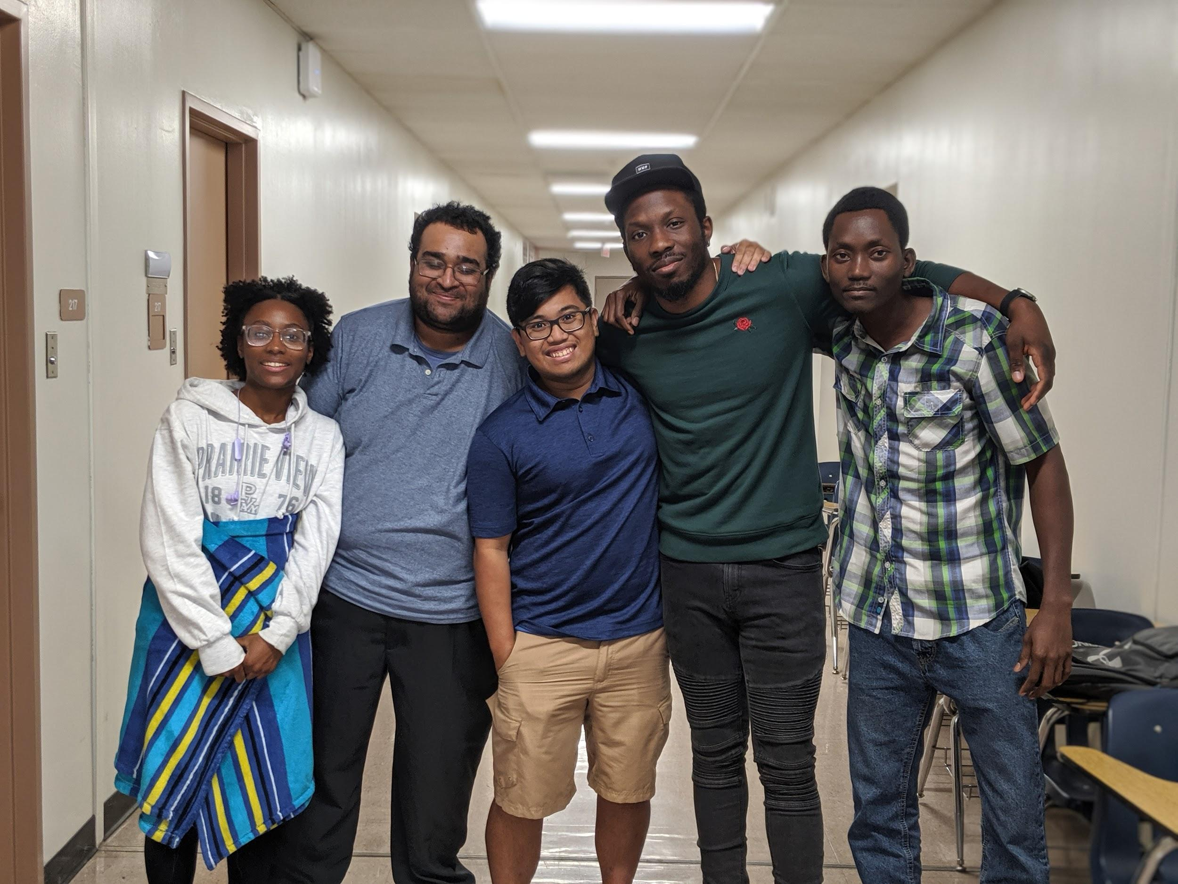

**Table of Contents**

**List of Figures…………………………………………………………………………………………………………………. 7**

**Chapter 1 - Problem Statement……………………………………….....………………………………………………. 8**

**1.1 Statement………………………………………………………………………………………………………. 8**

**1.2 Summary………………………………………………….………………………………………………….… 8**

**Chapter 2 - Introduction & Existing Work Survey………………………………..……………………………….... 9**

**2.1 Introduction…………………………………………………………………………………………………..… 9**

**2.1.1 General Interest Survey……………………………………………………………………….... 9**

**2.2 Existing Work…………………………………………………………………………………………………. 15**

**2.2.1 LoRa…………………………………………………………………………………………………. 14**

**2.2.2 IEM………………………………………………………………………………………………….. 15**

**2.2.3 NWave……………………………………………………………………………………………... 16**

**2.2.4 Smart Parking……………………………………………………………………………………. 17**

**2.2.5 Parking Space Detection in OpenCV………………………………………………………. 18**

**2.2.6 Dr. Yang’s Garage Application……………………………………………………………... 19**

**2.2.7 Rosim ITS Sensors..…………………………………………………………………………… 20**

**Chapter 3 - Project Timetable & Gantt Chart.………………………………………….……………………………. 22**

**Chapter 4 - Requirements & Usage Scenario…………………………………........................................... 24**

**4.1 Functional Requirements……………………………………………………………………………….… 24**

**4.2 Non-Functional Requirements…………………………………………………………………………… 24**

**System Architecture and Interface Design………………………..…………….**

**Module & Sub-Module Design & Function Description………………………**

**Requirement Validation…………………………………………………………………….**

**Risk Assessment and Planning……………………………………………………….…**

**Interface Implementation…………………………………………………………………**

**Implementation Technical Details…………………………………………………….**

**Test Plan & Test Results…………………………………………………………………..**

**User Operation Manual…………………………………………………………………….**

**Conclusions………………………………………………………………………………………**

**References………………………………………………………………………………………………………………….... 26**

**Appendices……………………………………………………………………………………….**

**List of Figures**

**Figure 1………………………………………………………………………………………………..……… LoRA’s System**

**Figure 2……………………………………………………………………………………………....... ProtoSense Sensor**

**Figure 3……………………………………………………………………………………………….. IEM Parking Network**

**Figure 4…………………………………………………………………………….... Flush - Mount IOT Parking Sensor**

**Figure 5………………………………………………………………………. Surface - Mount Parking Space Sensor**

**Figure 6……………………………....…….. Smart Parking Limited’s Sensors connected to digital signage**

**Figure 7…………………………………………………………………... Parking Space Detection Repository Flaw**

**Figure 8…………………………………………………………………………….……………………….... A Raspberry Pi**

**Figure 9……………………………………………………….. Rosim’s system using wireless gateway/sensors**

**Figure 10………………………………………………………...……… Screenshot of Critical Tasks in Gantt Chart**

**Chapter 1 - Problem Statement**

* 1. **Statement**

As university campuses continue to grow, so does the number of incoming freshmen with vehicles. Parking is a situation that plagues many and with such an influx of young students with cars it doesn't seem to be fixing itself anytime soon. Therefore, we need a reliable way to ensure that each student can reliably be able to park or find parking on campuses across the country so that no student is left behind.

* 1. **Summary**

We decided to look at the parking situation on college campuses and what we can do to alleviate the stress due to the rapid influx of incoming students. We will attempt to predict parking patterns on campus to allow both students and faculty to better plan where they can locate parking. To do so, we will attempt to create a mobile application using real-time data using a camera, machine learning, and the latest technologies. The current system is purely aesthetic and lacking functionality, therefore, we plan on creating a system that will accurately predict parking trends and provide real-time parking updates and availability.

**Chapter 2 - Introduction & Existing Work Survey**

**2.1 Introduction**

Universities are growing as more and more people seek higher education, and as these universities grow, so do their problems. Parking is one of the problems plaguing college campuses. As the student body grows, the amount of space available to park does not. There are many known working solutions to this issue which begs the question as to why none have been implemented or even attempted. The frustrations caused by campus parking and their so-called "parking management" frustrate students who are just trying to receive an education that they've paid for; an opportunity not afforded to everyone. We seek to investigate the main causes of the parking issue, develop a cost-efficient and effective solution that universities across the nation can use to alleviate the parking situations on their campuses. To do so, we will investigate the research and development of companies that have already created solutions and expand on their work.

**2.1.1 General Interest Survey**

In order to see if parking was truly a problem at our university, we conducted a survey for students and faculty to see how they felt about our parking situation. The survey consisted of nine questions; one of them asking for suggestions on what kind of functionality users would like to see in an application. Unfortunately, due to time constraints, we only received 36 responses. The results we obtained from that survey can be found below.

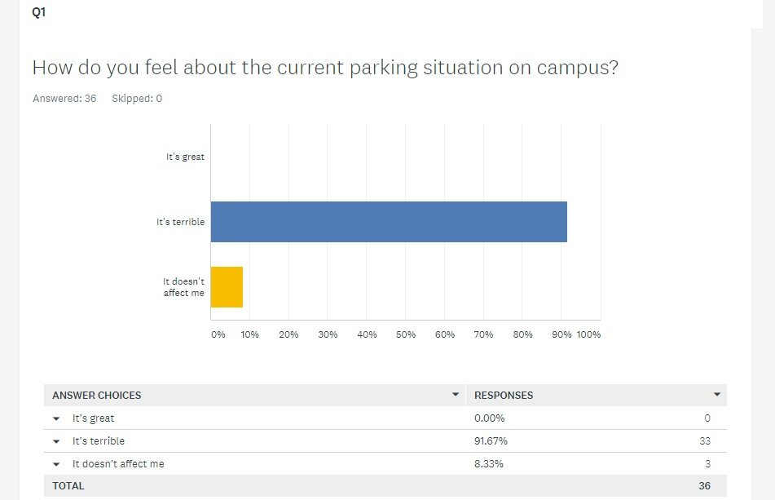

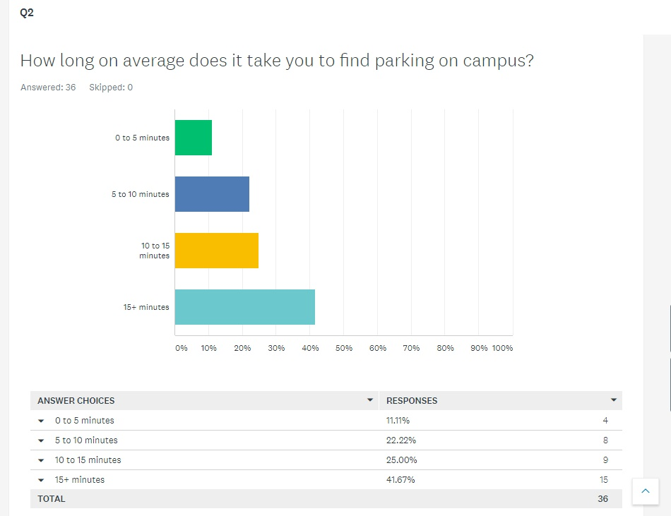

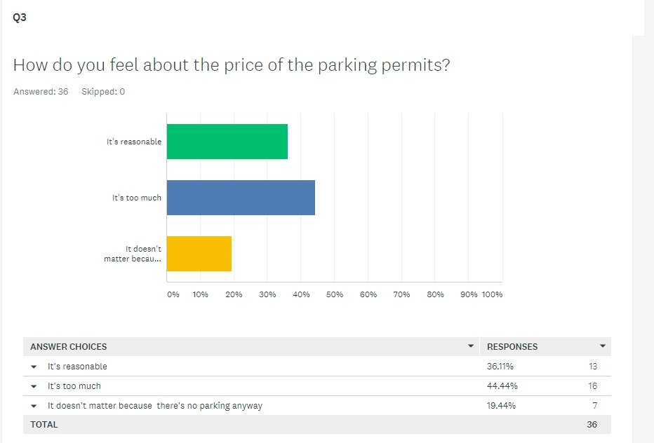

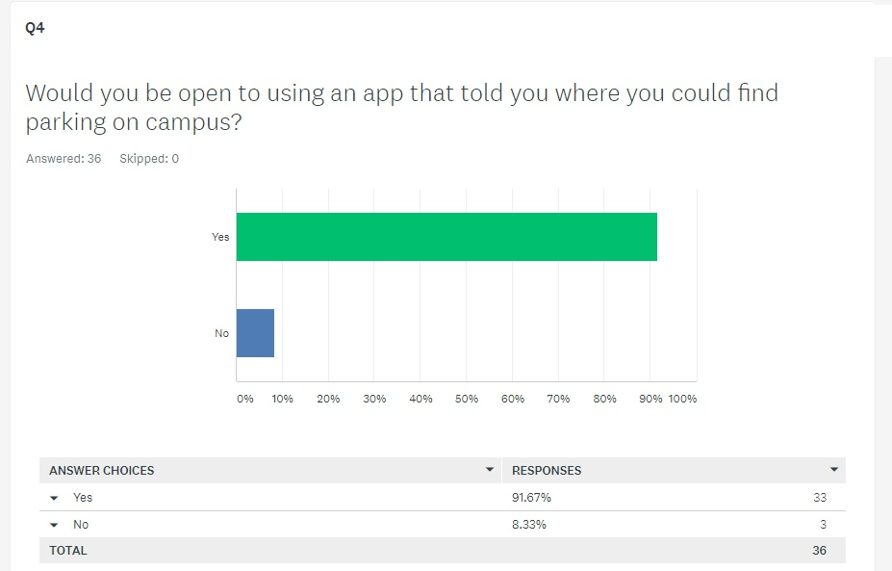

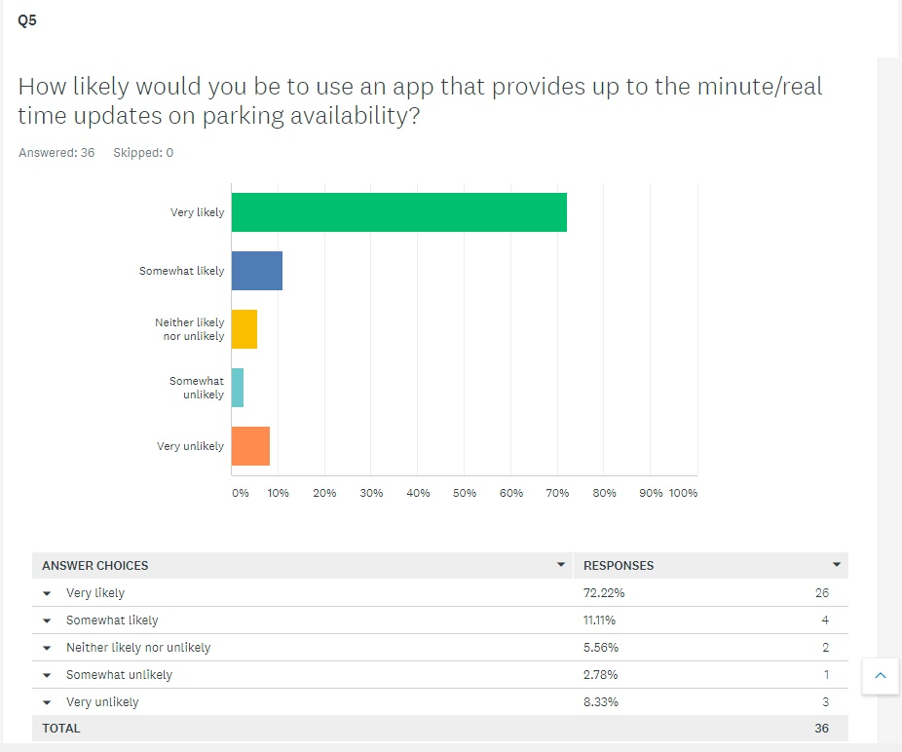

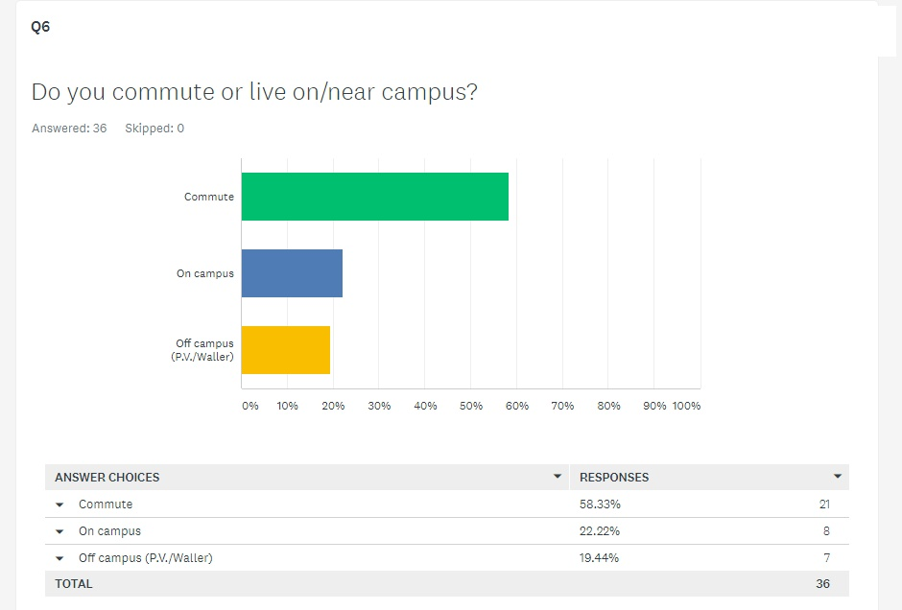

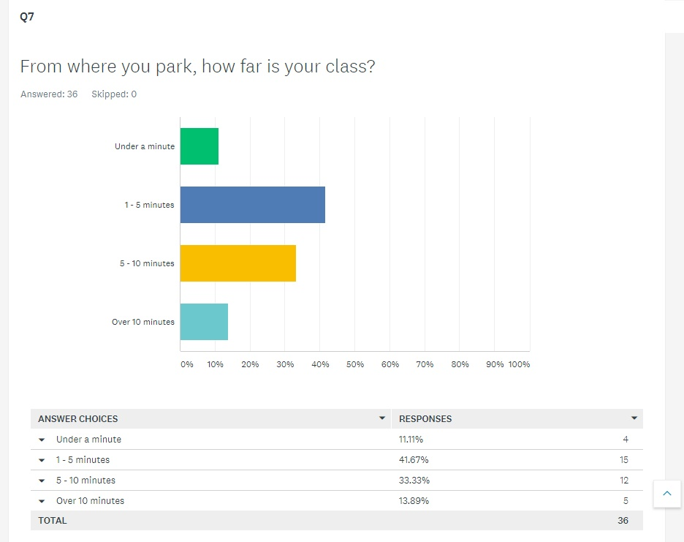

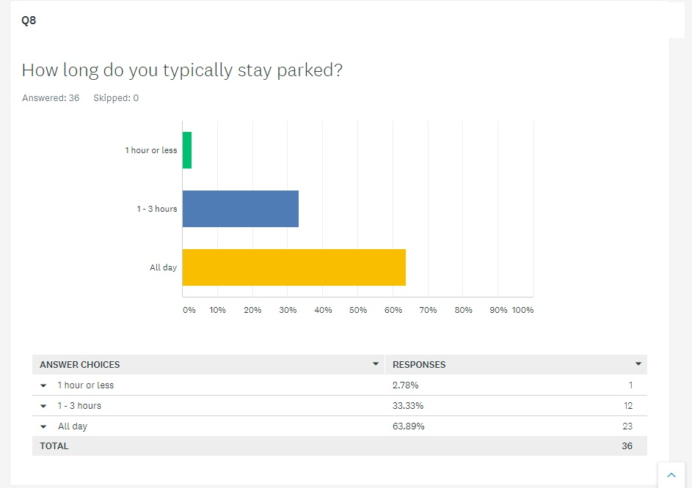

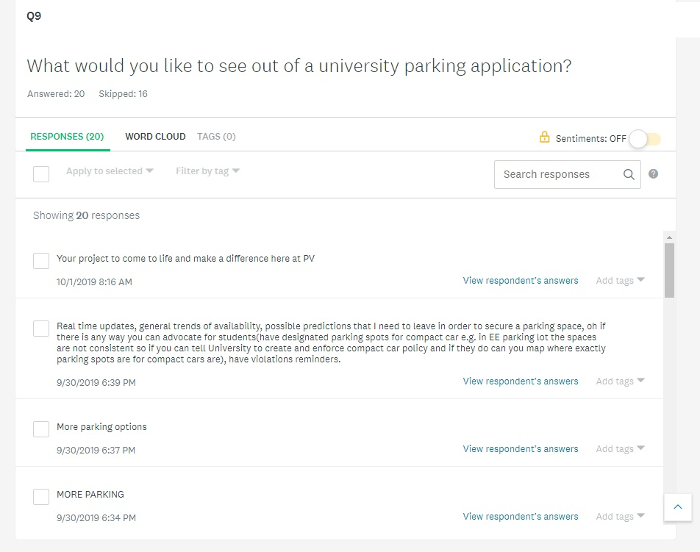

**2.2 Existing Work**

**2.2.1 LoRa**

LoRa, a Guangzhou KinouWell Tech creation, is a low maintenance solution to parking. The sensor enables us to manage real-time remote parking management, can support Bluetooth, and includes a mobile app with backend software.

The parking space sensor is for parking occupancy detection. It can detect when a car comes and leaves, and the data is sent to the gateway. There are 2 different types of wireless communication, one is LORAWAN, the other is NB-IOT. Their sensor can guide drivers to open parking spots and sends notifications to people parked too long in metered parking. It’s powered by a long-life battery(8+years), construction proof, and safe for any outdoor or indoor parking.

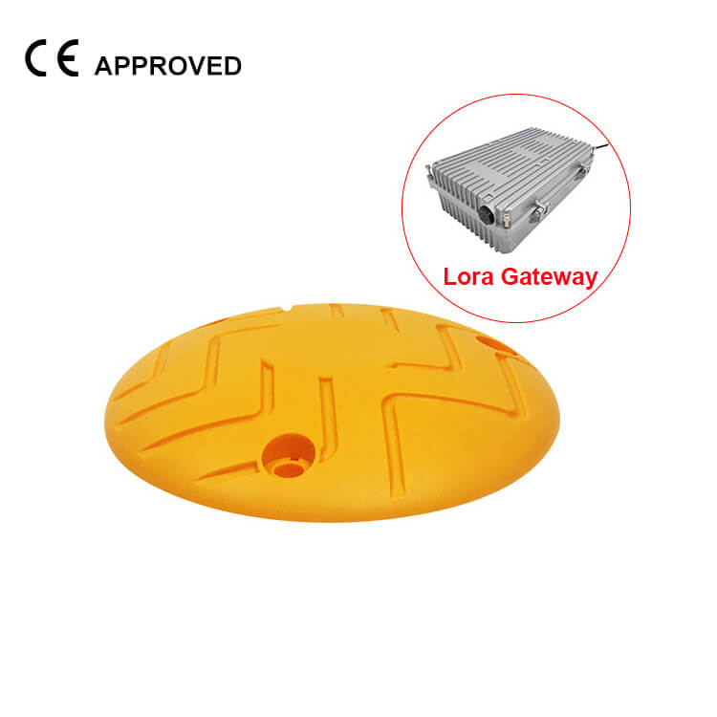

**Figure 1: LoRA’s system**

**2.2.2 IEM**

The company IEM (Ingenierie Electronique et Monetique) based in Europe specializes in smart parking management.[1] They provide solutions to street parking for both drivers and city officials, along. Drivers can use their mobile devices to check availability and municipality can easily monitor the trends and set their parking policies.

Regarding the technology behind, PrestoSense sensors are used for detection. They feature magnetic and ultrasonic and have a high reliability of up to 99% and are easily installed. The results of detection are sent to the parking platform every two seconds, from which an operator portal (city), motorist portal (drivers), and an interface to 3rd party apps (parking meter for example) are connected. The link is established via an IOT technology based on a low power WAN (LoRaWAN).

**Figure 2 : PrestoSense Sensor**

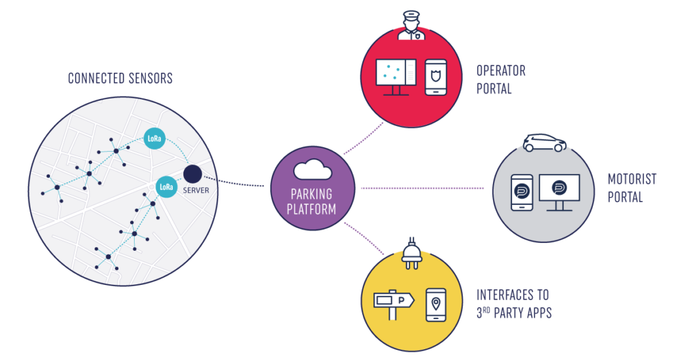

**Figure 3: IEM Parking Network**

**2.2.3 NWave**

NWave is a smart parking company that developed a wireless parking management system to optimize their client’s parking capacity. It utilizes wireless embedded sensors to detect which parking spaces are occupied or not.

In a recent case study, NWave and their application partner created a solution for the City of Harrogate in the UK to carry out parking laws and give its citizens the ability to search for parking spaces where they want to travel to within the city.[2]

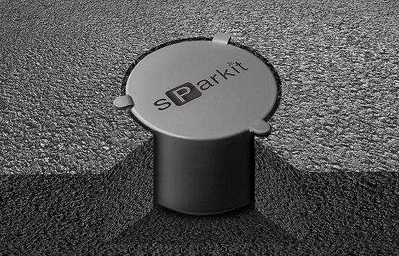

**Figure 4: Flush - Mount IOT Parking Sensor**

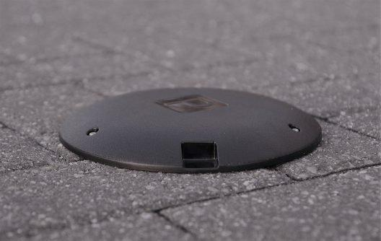

**Figure 5: Surface - Mount Parking Space Sensor**

**2.2.4 Smart Parking**

Like NWave, Smart Parking is another company that specializes in parking solutions. This company has an array of solutions such as the Smart Parking such as the Smart Parking App, Automatic Number Plate Recognition (ANPR) cameras, Digital Guidance Signage, Vehicle Detection, and much more.[3]

Their Vehicle Detection solutions offer both In-Ground Sensors and Overhead Indicator Sensors. Information from these are then absorbed into their cloud platform, SmartCloud, to control their Digital Guidance Signage

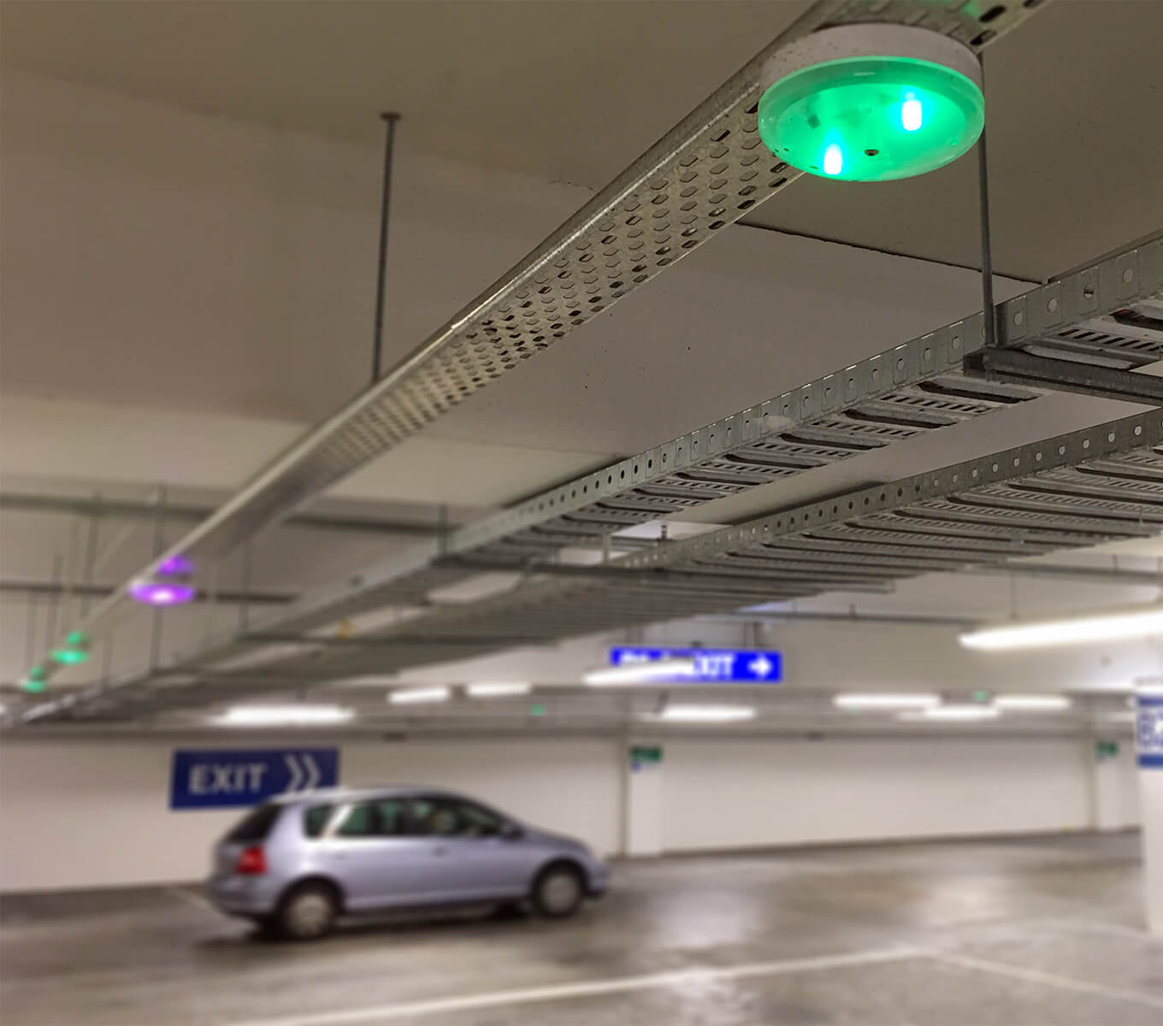

**Figure 6: One of Smart Parking Limited’s parking garage sensors that are connected to Digital Signs outside the facility**

**2.2.5 Parking Space Detection in OpenCV by OlgaRose**

Parking Space Detection in OpenCV is a repository created by a GitHub user named Olgarose.[4] This project utilizes a popular open-source computer vision and machine learning software library for programming languages like C++, Java, and Python.

According to the README, the user will first pass in parameters into the main python file. These parameters include a video of the parking lot being under surveillance, a still image from the video, and a path for the output file with the parking spaces’ coordinates. Main.py will prompt the user to draw rectangles for the spaces that they want to track. When done, the video that was passed in as a parameter will play with the coordinates and show the user which parking spaces are occupied.

The process tracking which spaces are occupied by drawing rectangles is simple. It takes each rectangle and analyzes the area and number of pixels within that area. With each frame of the video, this will repeat to see if any changes have occurred.

Unfortunately, the success of this method depends on many factors such as quality of video taken, camera used, lighting based on weather, and much more.

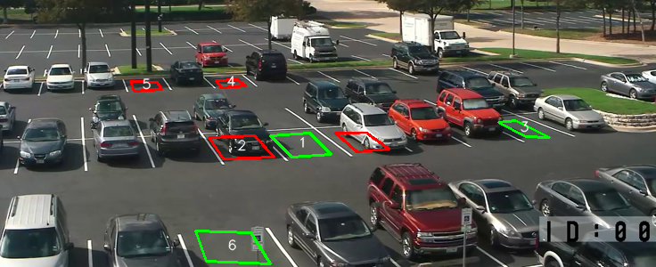

**Figure 7: The Parking Space Detection Repository has problems tracking spots 4 and 5 due to a cloud passing over the lot**

**2.2.6 Dr. Yang’s Garage Application**

In the early stages of our project, our group had a discussion with the Department Head of Computer Science, Dr. Yonggao Yang. We’ve discovered that he has implemented a similar system to what we’re trying to achieve. He essentially created a mobile application that will check if his garage is occupied and the ability to control his garage door.

His system is comprised of a Raspberry Pi and an ultrasonic sensor, which is powered by the garage door opener. All data collected by the sensor is then sent to a backend server where the application can use it to display on its frontend.

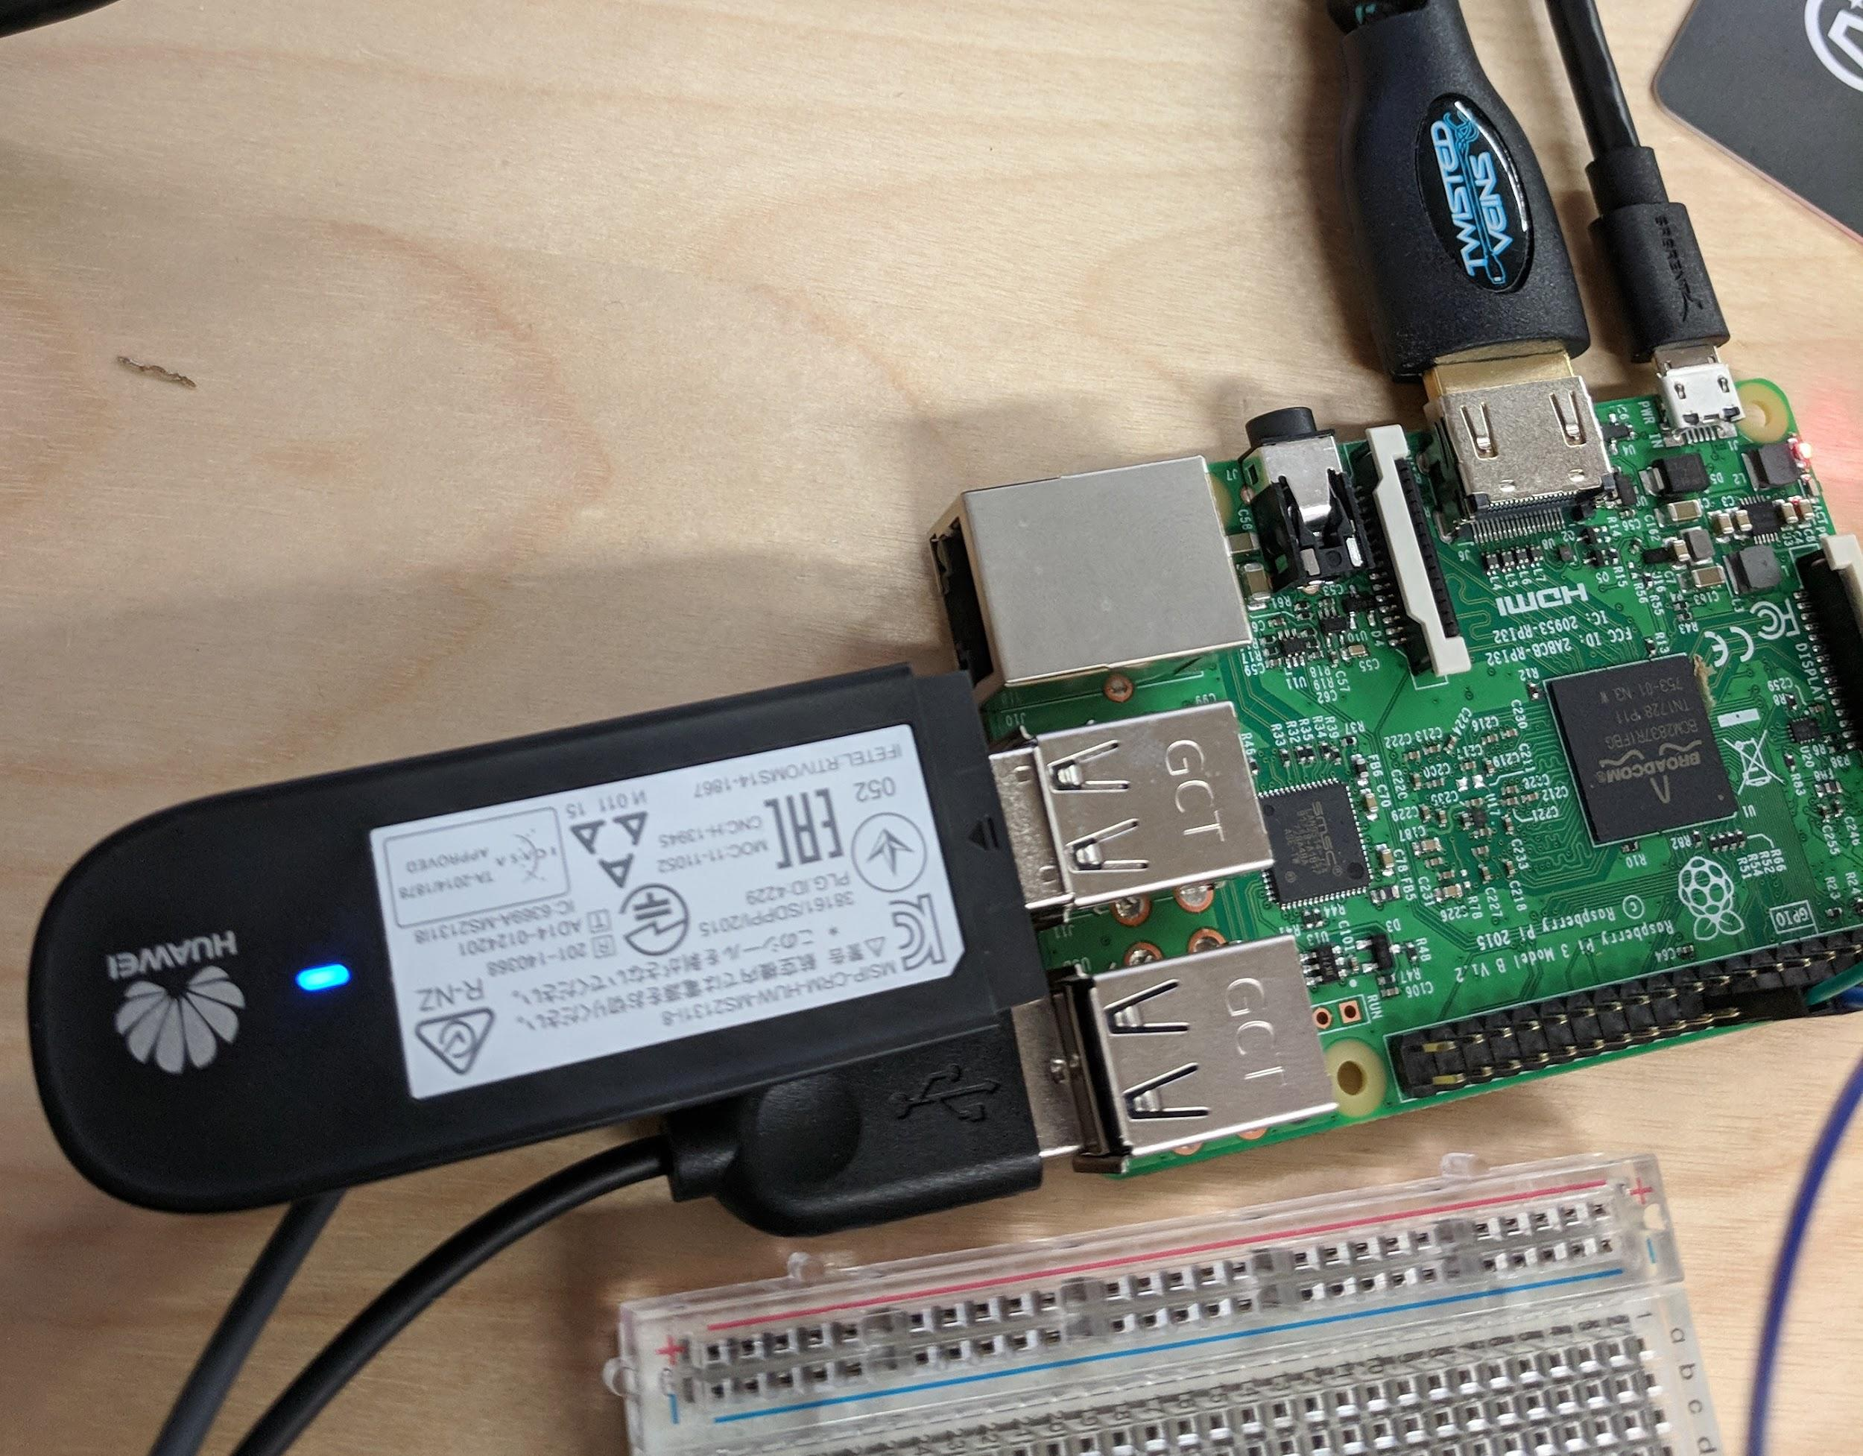

**Figure 8: A Raspberry Pi**

**2.2.7 Rosim ITS Sensors**

Rosim ITS (Zhongshan Rosim ITS Technology) is a Chinese tech company that focuses on parking management systems.[5] Their offerings include wireless parking studs that uses ultrasonic sensors to detect if a car is parked in that spot, as well as a gateway/server that receives signals from all the nodes and relays the number of free parking spots via an LED display However they do not have any sophisticated software offerings/apps to leverage the data their hardware generates, it is mostly limited to LED counters that you would see at the entrance of parking garages. They also have infrared and magnetic sensors in their offerings. (Zhongshan Rosim ITS Technology)

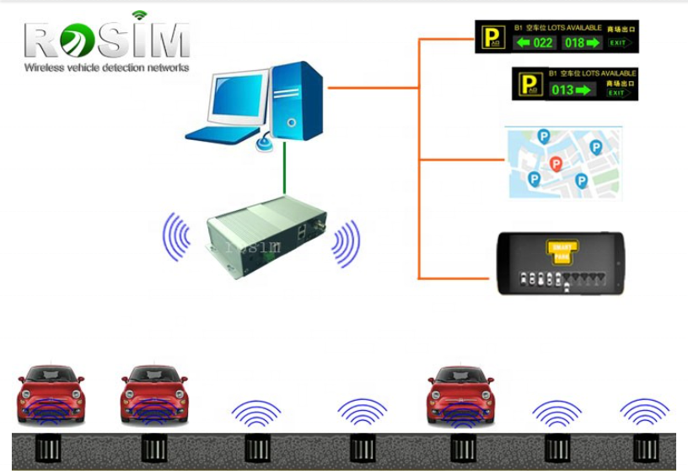

**Figure 9: Rosim’s system using wireless gateway/sensors**

**Chapter 3 - Project Time Table & Gantt Chart**

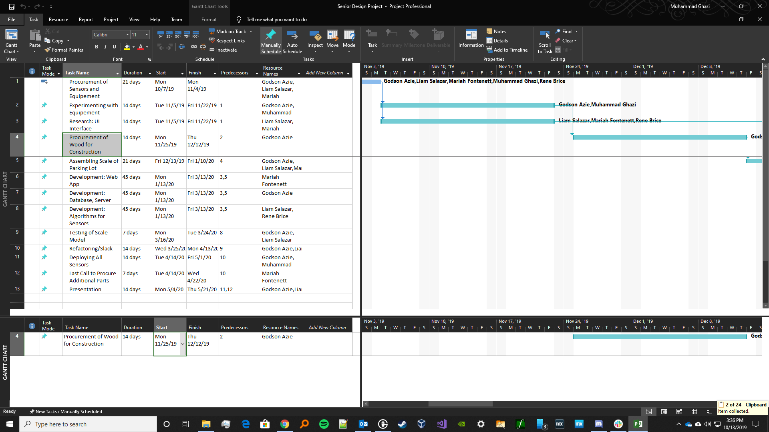**Figure 10: Screenshot of Critical Tasks in Gantt Chart**

|  |  |
| --- | --- |
| **Task Name** | **Description** |
| **Procurement of Sensors and Equipment** | **The group will gather research necessary for project items. At the end of the research process, we will be sending a document called “Project Item Requisition” to Dr. Yang and Dr. Huang.** |
| **Experimenting with Equipement** | **This time is dedicated towards familiarizing with the sensors and raspberry pi/arduino we requisitioned. This will also be the cutoff on ordering further electronics equipment** |
| **Research: UI Interface** | **Dedicated towards researching options and coming to a decision on which front end tech we will utilize. For example, will a web app suffice, or will we code an app for iOS/Android devices** |
| **Procurement of Wood for Cons.** | **Putting in an order for the wood/tools/scaffolding for our project** |
| **Assembling Scale of Parking Lot** | **Constructing a scale model of the parking lot, upon which we will install the sensors and wiring. Mostly using wood.** |
| **Development: Web App** | **Actual development and refactoring of our front end solution** |
| **Development: Database, Server** | **Working on our backend infrastructure, especially the DB, gateways and servers to handle requests from the front end** |
| **Development: Algorithms for Sensors** | **Backbone of our project, coding the algorithms that will utilize raw feed from the sensors and render data that will be relayed onto the app** |
| **Testing of Scale Model** | **One of the most important steps of development is to ensure that we test our application to mitigate security risks and maintain quality assurance** |
| **Refactoring/Slack** | **Refactoring is the process of making our code more efficient, removing any bugs and modifying the scope of our project. Any delayed tasks will use the slack in this timeslot. All dev tasks run concurrently so that refactoring can cover all software aspects of our project.** |
| **Deploying All Sensors** | **Final assembly of all sensors onto our wooden base/replica, end stage testing to check all facets of our project** |
| **Last Call to Procure Additional Parts** | **Self Explanatory. In accordance with deployment and refactoring we have this time period to order and install any hardware we need to complete project** |
| **Presentation** | **We will present the final product to the Computer Science faculty, students, and any guests that we may have during this event** |

**Chapter 4 - Requirements and Usage Scenario**

**4.1 Requirements**

**4.1.1 Functional Requirements**

* The system should monitor in real-time availability of a parking lot
* The app should display how many spaces are not taken
* The system should accurately determine occupancy regardless of the size of the vehicle
* The app should show on a map the locations of each spot, occupied or not
* Sensors should not trigger false positives
* Sensors should be able to determine whether a vehicle is occupying the space (object permanence)

**4.1.2 Non-functional Requirements**

* The system should update detection not more than every five seconds
* A user should not need to log in to check parking availability
* The detection system should not be affected by the weather
* The system should not establish a spot as occupied when someone is standing over it

**4.2 Usage Scenarios**

**Scenario 1**

1. John Smith is heading to campus but gets stuck in traffic
2. He would like to figure out between two parking lots near the building his first class is at
3. John checks the PV Parking app on his phone to find which one has more spaces available
4. The app displays each parking lot supported and their number of available spots
5. John continuously checks the spaces while driving to campus, and is already late at this point
6. John arrives on campus and heads straight to the most convenient lot, thus minimizing his tardy time

**Scenario 2**

1. Dr. Huang, best professor in the CS Dept, arrives on campus and heads to the Computer Science parking lot
2. He then uses the PV Parking app and selects the current lot he is in as he does not want to drive around and look for a spot
3. The app displays a representation of the lot with each spot and a color code for their occupancy
4. He finds a couple spots with that’s with a green dot, indicating a free space
5. Dr. Huang drives to the closest spot

**Scenario 3**

1. Jane Doe, an honors student, is driving to campus through a thunderstorm
2. She stops at the Buc’ees in Waller to check the PV Parking app and gets turkey jerky
3. She notices that all but a handful of parking spots in the far side of the lot, facing the PV facilities building are full
4. However, she knows that considering the downpour, these spots are probably under a few inches of water and might flood, as the water from the parking lot flows/drains there
5. Relieved with this knowledge, she chooses to park at another lot or wait safely at the Buc’ees until the weather improves

**Works Cited**

“Harrogate - Smart Parking Case Study by Nwave.” *NWAVE*, 31 July 2019, [www.nwave.io/case-study-harrogate/](http://www.nwave.io/case-study-harrogate/).

“Monitoring of Parking Spaces.” *IEM*, 2014 [www.iemgroup.com/solutions-products/presto-ecosystem/parking-space-monitoring/](http://www.iemgroup.com/solutions-products/presto-ecosystem/parking-space-monitoring/).

Olgarose. “Olgarose/ParkingLot.” *GitHub*, [github.com/olgarose/ParkingLot/blob/master/README.md](http://github.com/olgarose/ParkingLot/blob/master/README.md)

“Parking Lot Sensor Manufacturer - Kinouwell Tech.” *Tech Change Parking | Kinouwell Parking*,[www.kinouwellparking.com/product/parking-lot-sensor/?gclid=Cj0KCQjwt5zsBRD8ARIsAJfI4BhZXPSj5P1k79jQK_L2LOPl37y6i7h_L9uA9OKuJb-5pW_2E_ktRqcaAlJ4EALw_wcB](http://www.kinouwellparking.com/product/parking-lot-sensor/?gclid=Cj0KCQjwt5zsBRD8ARIsAJfI4BhZXPSj5P1k79jQK_L2LOPl37y6i7h_L9uA9OKuJb-5pW_2E_ktRqcaAlJ4EALw_wcB).

Smart Parking. “Smartpark System.” *Smart Parking*, 3 Sept. 2019, [www.smartparking.com/smartpark-system](http://www.smartparking.com/smartpark-system).

Zhongshan Rosim ITS Technology. *Rosim ITS Sensors*. 2019. <https://rosimits.en.alibaba.com/?spm=a2700.details.cordpanyb.1.23e94011BLsDQS>

1. “Monitoring of Parking Spaces.” IEM, 2014 https://www.iemgroup.com/solutions-products/presto-ecosystem/parking-space-monitoring/.
2. “Harrogate - Smart Parking Case Study by Nwave.” *NWAVE*, 31 July 2019, https://www.nwave.io/case-study-harrogate/.
3. Smart Parking. “Smartpark System.” *Smart Parking*, 3 Sept. 2019, www.smartparking.com/smartpark-system.
4. Olgarose. “Olgarose/ParkingLot.” *GitHub*, github.com/olgarose/ParkingLot/blob/master/README.md.
5. Zhongshan Rosim ITS Technology. *Rosim ITS Sensors*. 2019. https://rosimits.en.alibaba.com/?spm=a2700.details.cordpanyb.1.23e94011BLsDQS